Utilising Cross-Channel Recommender Systems to retain customers in online retail sales

# Contribution to the discipline

It has become increasingly challenging for businesses in a competitive marketplace to offer products and services that directly appeal to individual customer needs and preferences (Zhang, Lu and Jin,2020). Online retail sales have emerged as the leading method of shopping, providing consumers with personalised experiences tailored to their individual preferences. E-commerce recommender systems are indispensable tools in the current digital marketplace, shaping how consumers purchase products online (Salunke and Nichite,2022). Recommender systems are able to predict user preferences and suggest items that users are likely to be interested in and eventually purchase. However, traditional recommender systems have often relied on data from a single channel, such as past purchase data and website browsing history (Ibrahim and Saidu,2020). The increase in online e-commerce sites and social media marketplaces offers consumers immense choices, leading to increased competition for businesses. In order to boost cart value and improve customer engagement, there is a need to move away from traditional recommender systems to cross-channel recommender systems that consider the complex and fragmented customer journey.

The advancement in Machine Learning, Artificial Intelligence (AI) and data analytics has improved the technological development and application of recommender systems (Zhang, Lu and Jin,2020). AI techniques are increasingly being applied to recommender systems, enhancing the user experience and engagement. AI provides a higher quality of recommendation, creating advanced insights and relationships between different data points across multiple channels, whether it be social media, website browser history or mobile app data.

## Research Problem

The project aims to address the use of singular channel recommender systems and address the gaps in marketing by developing a recommender system that integrates data from multiple channels and provides a unified and consistent recommendation experience for the customer, with the end goal of improving customer engagement and retention, reducing dropout rates and cart abandonments.

## Contribution to the discipline

From a disciplinary perspective, the research contributes to the field of marketing, sales, business and in addition, machine learning, artificial intelligence and e-commerce by adopting unique methods and emerging trends to build cross-channel recommender systems.

# Aims and Objectives

Social media platforms such as TikTok, Facebook, WhatsApp and X have led to the emergence of new e-commerce models, termed Social Commerce by Busalim and Hussin, 2016). Social commerce refers to an online business model that leverages social technologies to facilitate user engagement within digital marketplaces and communities. This approach promotes the buying, selling, and sharing of product and service information within the community (Zhou et al. 2013). By aggregating and analysing various types of user-generated content, including text, images, and videos, social commerce allows businesses to access and understand a broader spectrum of consumers with greater efficiency than traditional offline retail channels (Yan et al. 2021).

This study aims to leverage user-generated content across multiple social media sites and merge the data with purchase history and browsing history to develop a recommender system that is persuasive enough to influence customer engagement and decisions. Previous research focused on the accuracy of recommender systems; however, researchers have since realised that accuracy alone is not a sufficient method of enhancing user acceptance (Alslaity and Tran, 2021). Research has been conducted on different persuasive principles that influence users of differing characteristics such as age, gender, culture and personality traits. In this study, the objective is to use the six principles of Cialdini (Cialdini, 2001), which are reciprocity, Commitment, Social Proof, Liking, Authority and Scarcity and develop a recommender system that applies these principles to data extracted from social media platforms, e-commerce websites and examines the user responsiveness.

Alslaity and Tran (2021) conducted a study on the influence of persuasive principles on user responsiveness within recommender systems through the administration of online questionnaires comprising two main sections: a personality assessment and a persuasion evaluation. The researchers examined how persuasive strategies impact users, taking into account user profiles defined by characteristics such as age, gender, culture, and personality traits. In the context of this research, user profiling will be derived from social media and e-commerce website data and categorised accordingly for targeted recommendations and persuasive interventions.

# Research Question.

## Primary Question

**How can a cross-channel recommender system, integrating data from social media, email, websites, and mobile apps, be designed and evaluated to enhance online retail sales and improve customer engagement?**

## Secondary Question

In what ways can data obtained from social media platforms be leveraged through persuasive techniques to enhance customer engagement and drive increased sales?

Answering these questions will enable the development of recommender systems that incorporate social commerce, leading to a more personalised and fulfilling online retail experience for users.

Methodology/development strategy

The development strategy will be as follows;

## Data collection

APIs will be used to collect data from the aforementioned social media channels (TikTok, Facebook, Instagram and X). For mobile apps and website data, web scraping techniques will be implemented. For the purpose of this study, the products that are the subject of the study will consist of consumer electronics, books and cosmetics. Social media data will be scraped from online retail stores’ pages. Additional data on purchase history and browsing data will be acquired through the customer relationship management software running the website backend. Data collected will form the data frame to be used in the analysis and modelling.

Data preprocessing and cleaning will be conducted to remove noise, handle missing values and standardise data formats. The proposed model for the recommender system is taken from (Padhy et al., 2024).

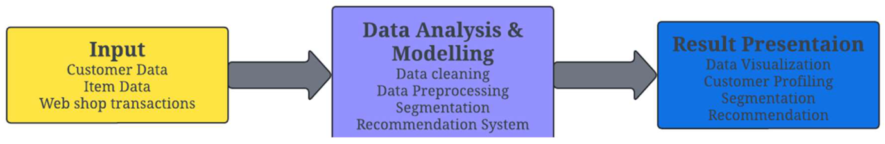

**Figure 1**: Proposed model for recommender system

Through the use of feature engineering, data will be transformed into meaningful features that capture underlying data patterns and relationships and thereby effectively classify data by utilising a set of measurable properties (Chandrashekar & Sahin, 2013). Raw data extracted from social media can be turned into informative features which machine learning models can use for various tasks such as user profiling, sentiment analysis and recommender systems. The common features which can be extracted from social media data could include textual features such as bag of words, converting text into numerical vectors, sentiment scores, and N-grams.

Features that can be extracted from both social media data and website data include user features, demographics, network features, i.e. the number of friends, followers, and friend connections and activity features comprising posting frequencies and engagement metrics, likes, comments and shares, which are useful in understanding the level of user activity and interest.

The feature engineering will allow for a detailed development of user profiles by aggregating data using the various features extracted from the data and categorising users based on demographics, engagement and behaviours.

The next part of the development strategy would be to develop the recommendation algorithm that integrates collaborative filtering with artificial neural networks while applying Cialdini’s six principles of persuasion to user data to improve the recommendation accuracy. Furthermore, studies by Valencia-Arias et al. (2024) will be adopted, in which recurrent neural networks are used to model data streams such as purchase history, browsing behaviour and for the purposes of this study, it will be further extended to user engagement on social media. In order for the persuasive recommendation system to accurately recommend products, social commerce elements need to be integrated, such as user-generated content, which consists of reviews, ratings, community interactions, i.e. Likes, Shares and reposts, offering a more immersive shopping experience.

# Ethical Considerations and Risk Assessment

Using AI and Machine learning algorithms to influence customer decisions and buying patterns raises ethical concerns and risks. Privacy concerns arise due to the harvesting and use of personal data to develop the machine learning algorithms used in recommender systems. Secure storage and responsible use of personal data should be heightened to protect individual privacy. At its core, this study can be argued to be extremely intrusive, relying on the big data-based consumer surveillance and the datafication of everyday life (Ball,2017). Furthermore, a study of this nature could lead to what Zuboff (2015) termed surveillance capitalism, where value is created through real-time surveillance of the activities and movements of people. This runs a risk of creating a production of prediction Mackenzie (2015), in which consumer tastes and choices and subsequently behaviours and identities are shaped by algorithms which update the environment according to consumer predicted needs with the ideal content.

Algorithmic bias in machine learning and AI-powered models raises significant concerns. Algorithms developed using machine learning or AI can produce unfair results, enhance inequalities that could lead to discrimination. Within a recommender system, algorithmic biases could have devastating impacts on customer groups, leading to unintentional discrimination.

# Evaluation Methods

A/B testing will be used to compare the effectiveness of the different versions of the digital asset. Metrics to be used to measure the system impact on user engagement and sales will include click-through rate, conversion rate and revenue per user. These will quantitatively track and measure the system. Click-through rate will measure the percentage of users who click on products that have been recommended. The conversion rate will measure the percentage of users who proceeded to purchase the recommended item. To calculate the economic impact of the system, the revenue per user is calculated as the average revenue produced by users of the system. Additionally, user satisfaction surveys will be conducted to assess the overall user satisfaction and experience. Further feedback analysis is required to identify common themes and areas of improvement in the system.

To mitigate and identify biases, the quantitative performance metrics and qualitative feedback and satisfaction surveys are combined to ensure that the evaluation of the recommender system encompasses the relevant business goals and user needs.

The recommender system’s success lies in its ability to offer novel and relevant suggestions that enhance the user experience (Meyer et al.,2012). Meyer et al. (2012) propose measures of performance that focus on four core functions. These are Help to Decide, where a potential customer is assisted in their decision-making process. A good, personalised rating prediction will help the potential customer to make a decision using the accuracy measure, Root Mean Squared Error (RMSE).

The second core function is Help to Compare, in which the potential customer is given a short list of relevant items after they have given their preferences (Meyer et al.). A ranking mechanism can be utilised in this regard. The third function is Help to Discover; the potential customer receives a list of recommended items. This will be calculated using a precision measure. Meyer et.al (2012) argue that precision alone will not guarantee the usefulness of the recommendation system. To account for this recommendation impact is proposed. The more frequently an item is recommended, the less impact the recommendation has; for this, the Average Measure of Impact (AMI) is used. Lastly, Help to Explore: the recommender system should be able to propose items similar to those either in the wish list, frequently being searched, or where customers within the same user profile have purchased or rated highly. For this k-Nearest Neighbour (KNN) model will be used to build a similarity matrix.

Using the aforementioned four core functions and associated performance measures, an evaluation protocol can be designed to measure the effectiveness of the recommender system.

# Timeline of Proposed Activities

The proposed timeline and associated activities span 12 months.

To build a robust recommender system, a structured timeline is proposed, commencing with the finalisation of the research design and conducting an extensive literature review. To begin the data collection exercise, relevant APIs need to be tested and evaluated. Data collection will be conducted across targeted social media channels, mainly X, TikTok, Facebook and Instagram. Additionally, data will be extracted from e-commerce platforms and customer relationship management systems. This will take approximately 2 months to complete. The next stage is the data processing and feature engineering, which will stretch for 3 months. The model development and system testing are expected to take at least 4 months, and finally, the evaluation and reporting will be done over 4 weeks.

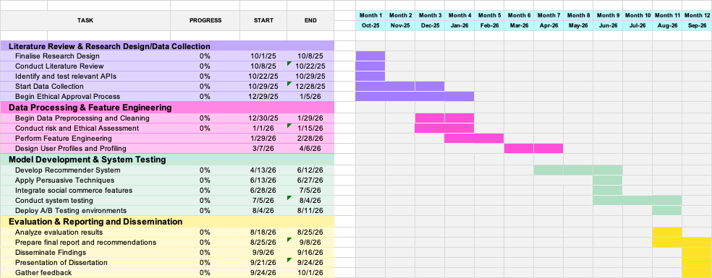Gantt Chart: Timeline of Proposed Activities

Figure 1: 12 Month Gantt Chart: Cross-Channel Recommender System Development

# Key Literature Related to the Project

The key literature related to this project will focus on cross-channel recommender systems and the utilisation of social media data for enhancing recommender systems in retail environments.

On the development of cross-channel recommender systems, Sachdeva & McAuley (2020) highlighted that data silos, inconsistent data formats across different channels can hinder the development of a unified customer view. The authors proposed the implementation of standardised data models, data governance polices and real-time data synchronisation mechanisms to ensure data consistency. Portugal et al. (2015) research pointed out the challenges that stem from integrating a recommender system across multiple retail sales channels. The authors noted a major obstacle of combining and reconciling data from different sources, such as online browsing behaviour, mobile apps usage and social media interactions. Zhang, Ji & Cai (2025) further highlighted the ethical considerations that arise when social media data is integrated into recommender systems. The authors pointed out that data privacy, security, user consent and algorithmic transparency need careful consideration.

On the ethics of cross-channel recommendation systems, Krauth, Wang & Jordan (2022) argue that the interplay between recommendation systems and user behaviour could introduce feedback loops that can inadvertently compromise recommendation quality and homogenise user preferences. The authors propose the use of Causal Adjustment for Feedback Loops (CAFL), an algorithm that breaks feedback loops using causal inference. To address these challenges, Padhy et al. (2024) suggest incorporating a holistic approach that considers the entire retail ecosystem. This includes data collection and integration into the development of models to create a personalised shopping experience.

## References

1. Zhang, Q., Lü, J. and Jin, Y. (2020) “Artificial intelligence in recommender systems,” Complex & Intelligent Systems, 7(1), p. 439. doi:10.1007/s40747-020-00212-w.
2. Salunke, T. and Nichite, U. (2022) “Recommender Systems in E-commerce,” arXiv (Cornell University) [Preprint]. doi:10.48550/arxiv.2212.13910.
3. Ibrahim, M.S. and Saidu, C.I. (2020) “Recommender Systems: Algorithms, Evaluation and Limitations,” Journal of Advances in Mathematics and Computer Science, p. 121. doi:10.9734/jamcs/2020/v35i230254.
4. Busalim, A.H., Hussin, A.R.C. and Iahad, N.A., 2019. Factors influencing customer engagement in social commerce websites: A systematic literature review. Journal of theoretical and applied electronic commerce research, 14(2), pp.1-14.
5. Zhou, L., Zhang, P. and Zimmermann, H.D., 2013. Social commerce research: An integrated view. *Electronic commerce research and applications*, *12*(2), pp.61-68.
6. Yan, J., Leidner, D. E., Benbya, H., and Zou, W. (2021). Examining interdependence between product users and employees in online user communities: the role of employee-generated content. J. Strateg. Inf. Syst. 30:101657. doi: 10.1016/j.jsis.2021.101657
7. Alslaity, A. and Tran, T. (2021) “Users’ Responsiveness to Persuasive Techniques in Recommender Systems,” Frontiers in Artificial Intelligence, 4. doi:10.3389/frai.2021.679459.
8. Cialdini, R., 2001. Principles of persuasion. Arizona State University, eBrand Media Publication.
9. Padhy, N., Suman, S., Priyadarshini, T.S. and Mallick, S., 2024. A Recommendation System for E-Commerce Products Using Collaborative Filtering Approaches. *Engineering Proceedings*, *67*(1), p.50.
10. Chandrashekar, G., & Sahin, F. (2013). A survey on feature selection methods. Computers & Electrical Engineering, 40(1), 16. <https://doi.org/10.1016/j.compeleceng.2013.11.024>.
11. Valencia-Arias, A., Uribe-Bedoya, H., González-Ruiz, J.D., Santos, G.S., Ramírez, E.C. and Rojas, E.M., 2024. Artificial intelligence and recommender systems in e-commerce. Trends and research agenda. *Intelligent Systems with Applications*, *24*, p.200435.
12. Ball, K. (2017) “All-consuming surveillance: surveillance as marketplace icon,” Consumption Markets & Culture, 20(2): 95–100.”
13. Zuboff, S. (2015) “Big other: surveillance capitalism and the prospects of an information civilization,” Journal of Information Technology, 30(1): 75–89.”
14. Mackenzie, A. (2015) “The production of prediction: what does machine learning want?” European Journal of Cultural Studies, 18: 429–445.”
15. Meyer, F., Fessant, F., Clérot, F. and Gaussier, E., 2012. Toward a new protocol to evaluate recommender systems. *arXiv preprint arXiv:1209.1983*.
16. Sachdeva, N. and McAuley, J. (2020) “How Useful are Reviews for Recommendation? A Critical Review and Potential Improvements,” p. 1845. doi:10.1145/3397271.3401281.
17. Portugal, I., Alencar, P.S.C. and Cowan, D. (2015) “Requirements Engineering for General Recommender Systems,” arXiv (Cornell University) [Preprint]. doi:10.48550/arxiv.1511.05262.
18. Padhy, N. et al. (2024) “A Recommendation System for E-Commerce Products Using Collaborative Filtering Approaches,” p. 50. doi:10.3390/engproc2024067050.
19. Krauth, K., Wang, Z. and Jordan, M.I. (2022) “Breaking Feedback Loops in Recommender Systems with Causal Inference,” arXiv (Cornell University) [Preprint]. doi:10.48550/arxiv.2207.01616.
20. Zhang, C., Ji, X. and Cai, L. (2025) “Clothing Recommendation with Multimodal Feature Fusion: Price Sensitivity and Personalization Optimization,” Applied Sciences, 15(8), p. 4591. doi:10.3390/app15084591.